城市高架Urban Elevated Highway
1.城市高架（348国道）——路程：10公里，25分钟。1. Urban Elevated Road (National Highway 348) — Distance: 10 km, 25 minutes
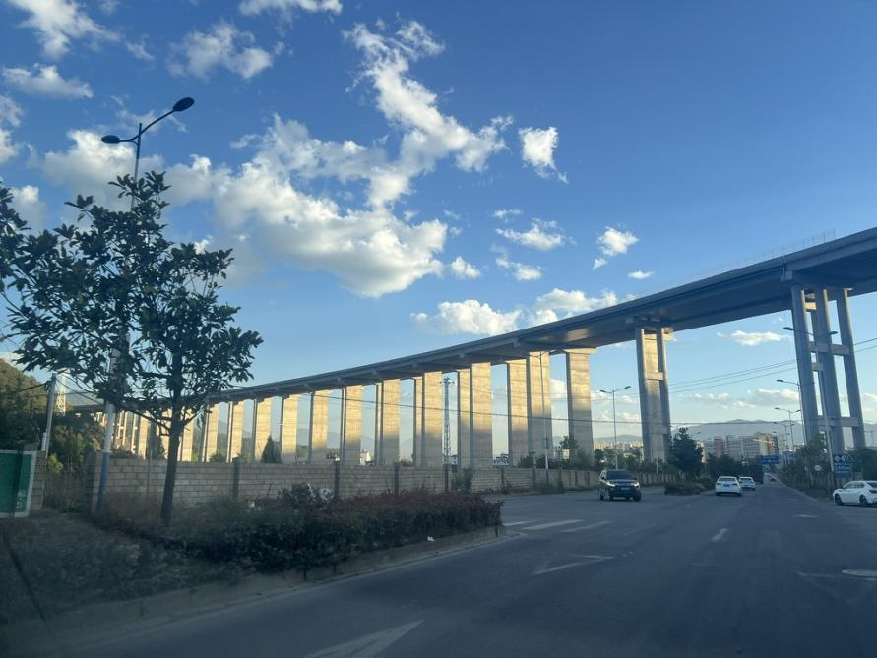
任送英子到上海郊区下车。Ren Xiatian dropped Yingzi off in the suburbs of Shanghai.

